TRIBHUVAN UNIVERSITY

**PATAN MULTIPLE CAMPUS**

LAB REPORT ON: IIT

LAB REPORT NO: …..

|  |  |
| --- | --- |
| **SUBMITTED BY** | **SUBMITTED TO** |
| NAME: SURESH DAHAL | DEPARTMENT OF IT |
| CLASS: BIT – I/I – A |  |
| ROLL NO: 23 |  |
| DATE: ……………… | |

**TITLE: FAMILIARIZATION WITH COMPUTER HARDWARE COMPONENTS**

**Theory:**

Being familiar with the machine we will be using is crucial. So, in this lab, we are going to look into different computer hardware components to understand their role in computer operation and how they looks like.

Some important computer hardware components are given by:

1. **Central Processing Unit (CPU)**: CPU contains different parts such as registers memory, ALU, control unit etc. to perform any arithmetic and logical operation in a computer. It is tiny but heavy hardware components that acts as a brain of the computer.

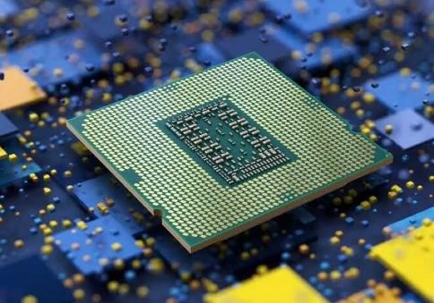

Figure 1: CPU

2. **Motherboard**: This primary circuit board hosts the CPU, memory, and other critical components, and provides the necessary interfaces for connecting peripherals.

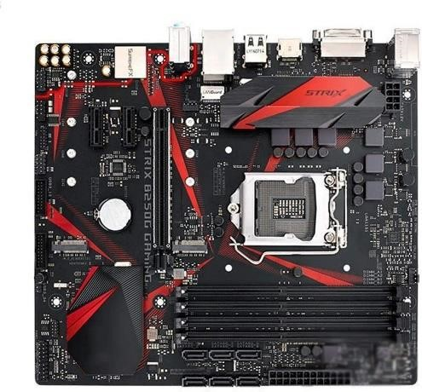

Figure 2: Motherboard

3. **Memory (RAM)**: Random Access Memory is the primary temporary storage device that the CPU uses for quick data retrieval. It is faster but expensive memory used to make overall computation faster.

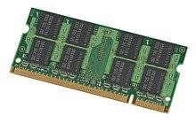

Figure 3: RAM

4. **Secondary Storage Devices**: These are used for storing large data permanently, with HDDs and SSDs being common examples. SSDs are known for their faster data access speeds.

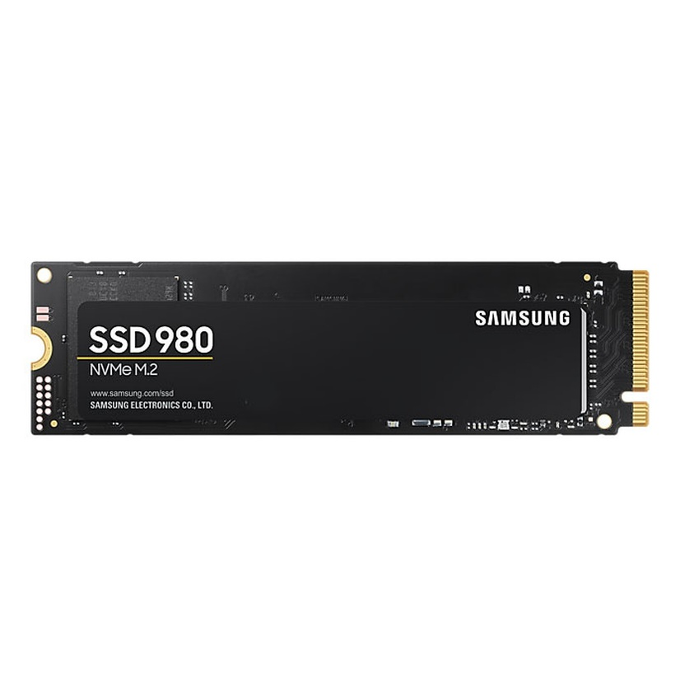

Figure 4: SSD

5. **Graphics Processing Unit (GPU)**: Specialized for processing visual content, the GPU is essential for rendering graphics for applications like gaming, animation, VFX and video production.

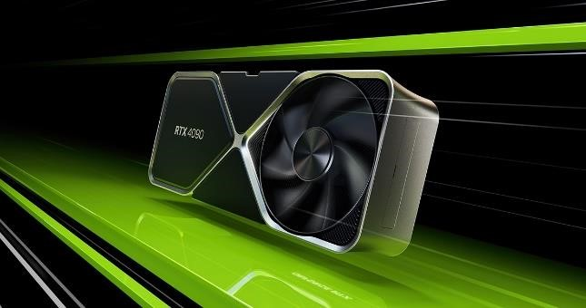

Figure 5: GPU

6. **Power Supply Unit**: This hardware component acts as rectifier to convert AC mains from wall socket to DC of suitable voltage to be used by the computer.

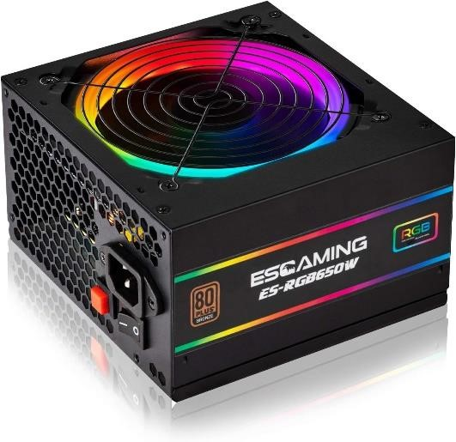

Figure 6: Power Supply Unit

7. **Ports**: Connectors on the computer for interfacing with external devices, including USB (Universal Serial Bus) for peripherals, HDMI and DisplayPort for video output, Ethernet for networking, and audio jacks for speakers and headphones.

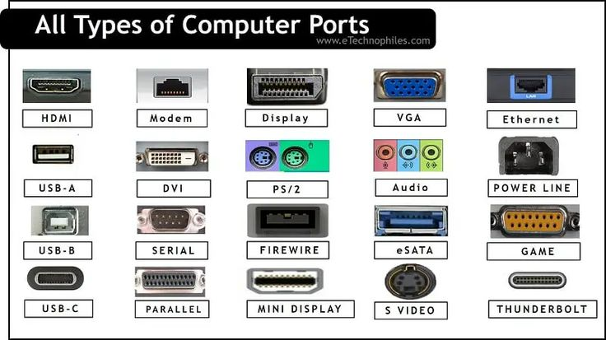

Figure 7: Computer ports

8. **CPU Fan:** While CPU does some heavy computation or processing, it generates a lot of heat. That heat has potential to damage the CPU and its neighboring components. So, to prevent that, there’s a heat sink and a fan used to cool it down.

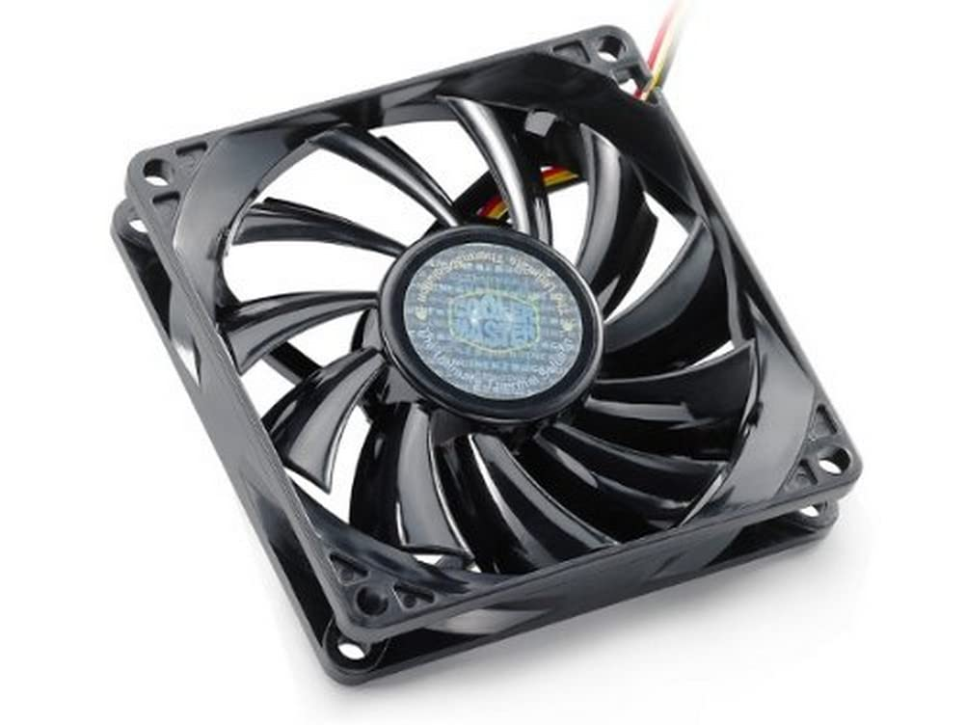

**CONCLUSION:** In this lab, we have explored different computer hardware components and tried to understand why those components are there and why are they important in their place. We understood how they are placed inside the computer casing box.